To begin, make sure that you have followed the instructions in the Project Specification to generate a stimulus control (.SCL) file, and those to create a stimulus control scenario.

Using the Stopwatch

Make sure that you have selected MPLAB SIM as your debugging tool. Open a Stopwatch Window by choosing Debugger > Stopwatch

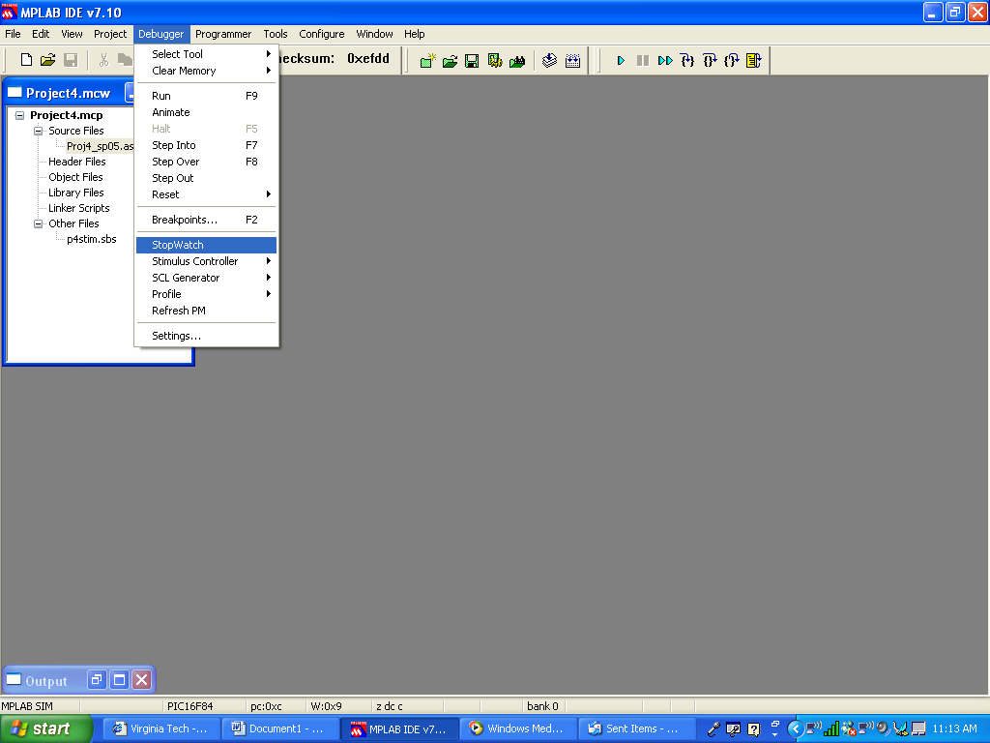

This is what the Stopwatch looks like:
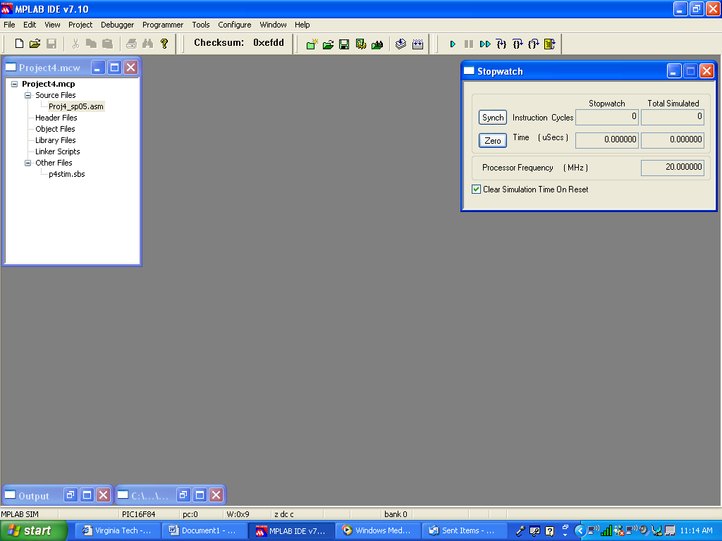

The Stopwatch will keep track of both the number of instruction cycles that have taken place since the last processor reset, and (based on the processor frequency) the amount of time that has passed since the last processor reset. If you make sure that the “Clear Simulation Time On Reset” dialog box is checked, the Stopwatch settings will reset on each Processor Reset.

Since each event in the stimulus file occurs after a certain number of instruction cycles have passed, we can use the Stopwatch to note exactly when something should happen in the program. We still need the means to watch the program execute, and to watch certain file register values undergo changes. That fact aside, we can use the stimulus file to figure out exactly what should happen, and when it should happen.

Here is a picture of the SCL workbook:

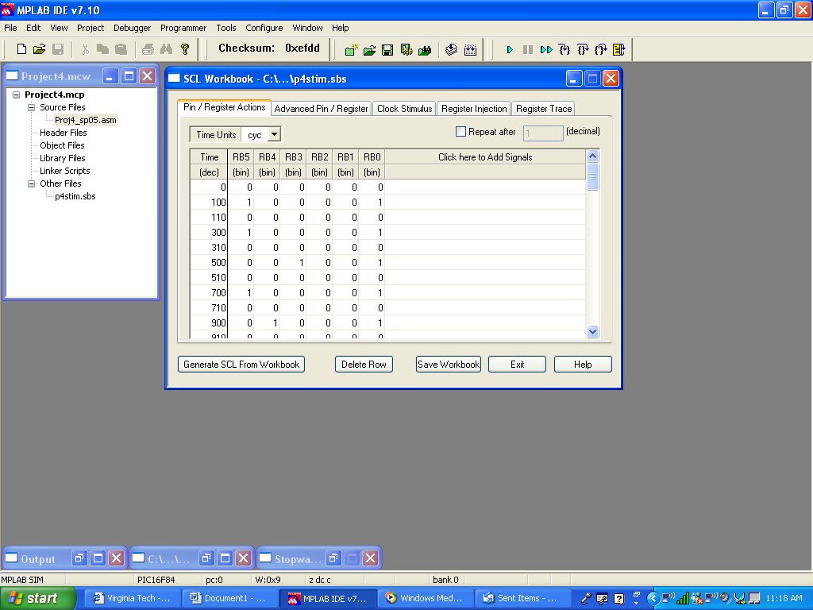

Think of what you see as a Logic Works input timing file. At time 0, none of the pins of PORTB are set. At time 100, two pins of PORTB are set: RB5 and RB0. RB0 is the interrupt pin. Each time the interrupt pin is asserted, the program will stop whatever it is doing and execute the interrupt service routine that starts at program memory address 0x04. Pin RB5 is the pin that corresponds to a quarter having been placed into the coin slot. The value of PORTB (sans RB0, since it gets masked out) will find its way into the register called INVAL during the interrupt service routine. At time 110, the value in PORTB disappears – presumably, the coin has dropped into the slot, and the interrupt is no longer required.

Once the interrupt service routine ends, your program will return to the polling routine in the MAIN routine. Since the interrupt service routine sets the semaphore flag, the condition being polled is satisfied, and your program will enter into the section where it has to do everything needed:

- Update the total value of the money that has been placed into the machine (if a coin has been deposited), -and-
- Dispense anything that is required:
  - The coins that have already been deposited if the Coin Return input has been asserted or if a penny was the last coin to be deposited,
  - A soda, if the total value of the coins deposited is sufficient,
  - Change, if the total value of the coins deposited exceeds the cost of a soda.
Now we need to set up the means by which we can observe these things happening.

Creating a Watch Window

Make sure that you have assembled your program, so that the simulator can make the correct symbolic label associations. Open a Watch Window by choosing View > Watch.

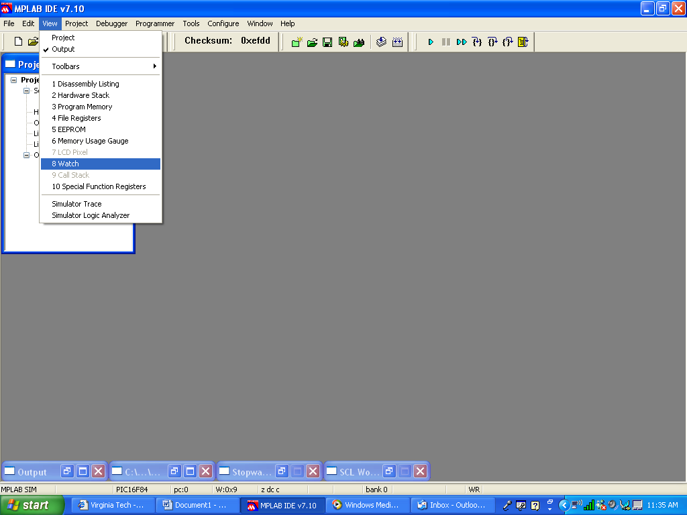

This is what a Watch Window looks like:

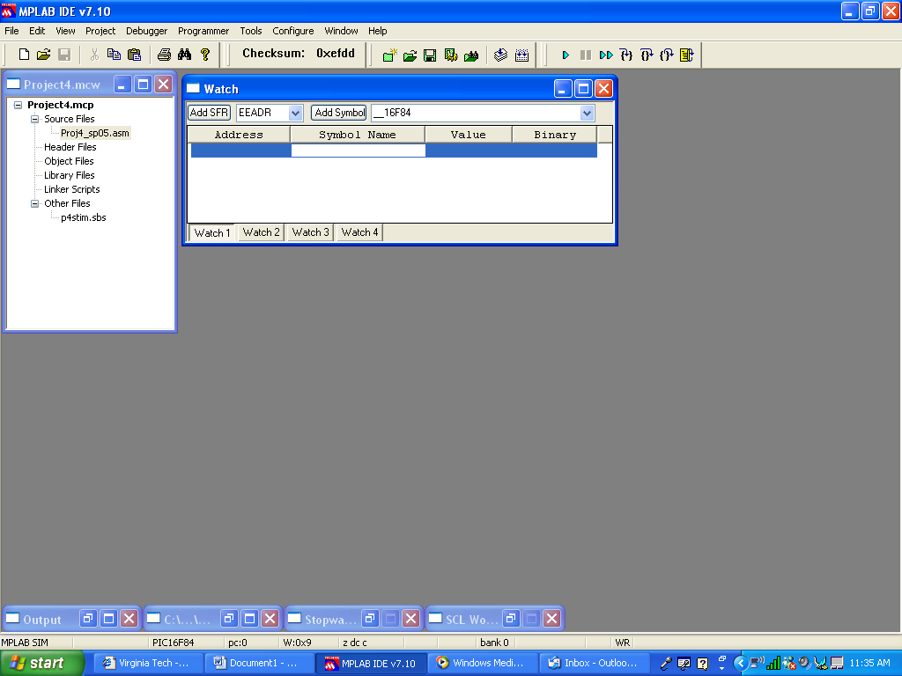

The Watch Window will allow us to observe the contents of specific addresses in File Memory. We can choose addresses that correspond to Special Function Registers (like PORTB) by choosing them from the left pull-down menu.

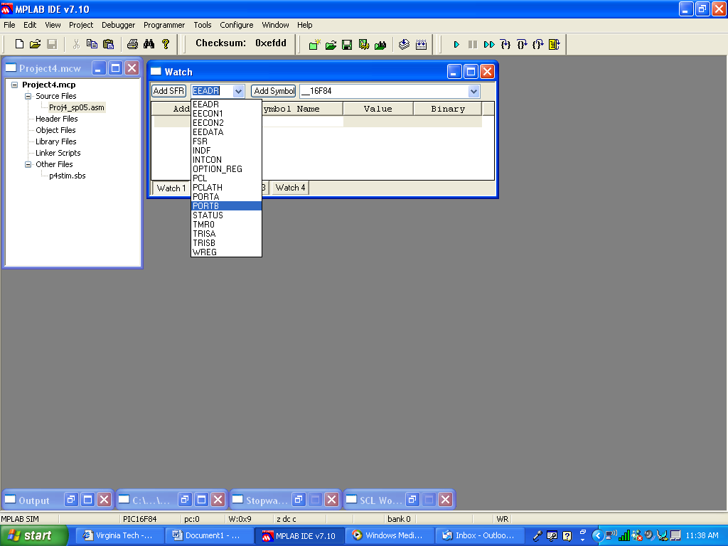

Once you have chosen a SFR, press the “Add SFR” button to add it to the Watch Window.

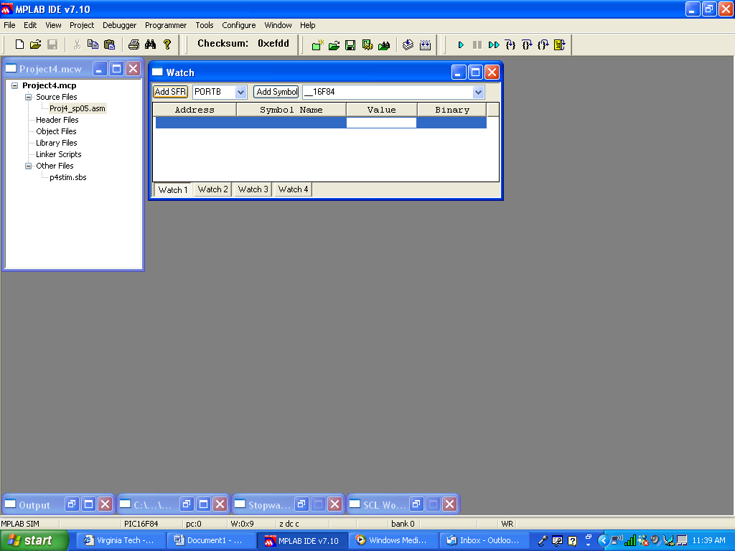
Once you press the “Add SFR” button, the register appears in the Watch Window, identified by its address and (if appropriate) its symbol name.

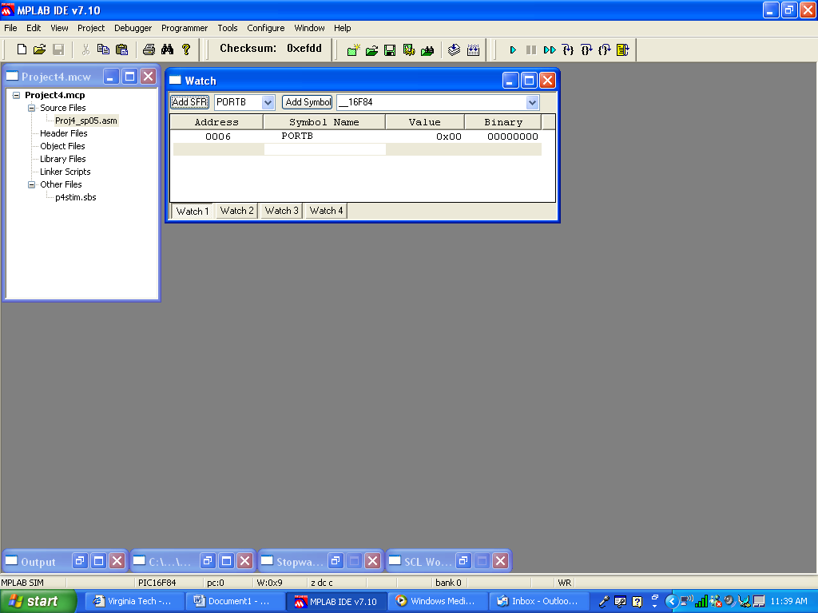

We will add other register values to the Watch Window – specifically, those whose contents play a role in verifying that the program works the way that it should.

Specifically, these are the registers that we should watch for important events:

Label | Address | Function
WREG | (none) | The working register is the destination of many possible operations of the program. Watching its contents will tell us if the logic of our program is correct
PORTB | 0x06 | PORTB receives the input representing the interrupt, along with the coin deposited (if one was deposited) or the assertion of the coin return.
inval | 0x25 | INVAL receives a copy of the contents of PORTB during the interrupt service routine, but without the least significant bit – the value on interrupt pin RB0.
semaphore | 0x26 | Bit 0 of SEMAPHORE must be set in order to satisfy the condition of the polling routine that starts MAIN. The bit is set during the interrupt service routine.
totalcoins | 0x20 | TOTALCOINS holds the current value of the coins deposited during the program’s operation.
releasecoke | 0x12 | RELEASECOKE contains the value 0xFF during the period in which a soda is dispensed. This value should only appear in this address if the value of TOTALCOINS is sufficiently high.
allreturn | 0x10 | ALLRETURN must contain the value 0xFF as the result of any event that requires a “coin dump” – the return of all coins deposited up to that point.
somereturn | 0x11 | SOMERETURN must contain a value that corresponds to the value of the coin being returned as change once a soda has been dispensed.

While the above registers are not listed in numerical order (especially since the working register doesn’t have a file memory address), this is a logical order to observe the goings on in the program:

- Once an interrupt occurs, the base program will take the value in PORTB into the working register. Using the Stopwatch and the Stimulus File, you will want to verify that the correct value appears in PORTB at the correct time.
- The interrupt service routine moves a masked version of PORTB into INVAL, through the working register.
- The interrupt service routine sets bit 0 of SEMAPHORE, so that the polling routine in MAIN will be satisfied after the return from interrupt.

Now we’re into the part of the program that you have to write.

- You’ll want to verify that TOTALCOINS has the right running total as a result of each coin that is deposited.
- You’ll want to see RELEASECOKE receive (and be cleared of ) the right value in the event that the value of TOTALCOINS is sufficiently high.
- You’ll want to see ALLRETURN receive (and be cleared of) the right value as the result of any condition that causes a coin dump.
- You’ll want to see SOMERETURN receive the right value (or sequence of values) as the result of change being returned to the buyer after RELEASECOKE cycles through the correct set of values.

Before we talk about adding these values, let’s add some more information to the Watch Window. Right-click on the tab next to the tab labeled VALUE. If BINARY doesn’t already appear as a column header in the Watch Window, choose BINARY from the list of menu options. This will show the binary equivalent of the hexadecimal value shown as the contents of the given address. Depending on how your default Watch Window is set, you can choose other options such as DECIMAL and HEX. You can use the same method to remove column headers.

It makes sense to watch the contents of the various registers as they would be expressed in different radices. For example, the contents of PORTB and INVAL are best observed as binary values, since the individual bits of the input value from PORTB have different significances. The same is true of SEMAPHORE. TOTALCOINS contains the total value of the coins that have been inserted, so it makes sense to watch the decimal value. RELEASECOKE, ALLRETURN, and SOMERETURN have specific hexadecimal values written to them when a specific event occurs.

Let’s add some of these registers to the Watch Window. Since most of them are signified by symbolic labels, we should be able to add them by finding them on the Symbol pull-down menu and then pressing the “Add Symbol” button. But it’s possible that it won’t be that easy.

For some reason, the use of the reserve statement for file register “allocation” doesn’t associate the label in question with the value of its address. It happens on the Symbol Table, but not on the list of labels that can be selected in the Watch Window.

Barring the use of equate statements (which is the best way to make sure that a symbol is associated with its corresponding value), we can use the CBLOCK to associate those labels that we expect to use as file memory address labels. In the case of this program, the following label blocks could be used to make the same associations as are presently being made by the reserve statements.
; Define memory areas for output.
; These definitions at 0x10 are supplied to the user and must not be modified.

cblock 0x10
allreturn ; Write 0xFF to this address to return all coins.
somereturn ; Write 0x01 to this address to return a nickel.
; Write 0x02 to the same address to return a dime.
releasecoke ; Write 0xFF to this address to dispense a soda.
endc

; Define the data storage locations.
; These definitions at 0x20 are supplied to the user and must not be modified.

cblock 0x20
totalcoins ; The total amount of money inserted so far.
tempw ; A location to hold W during the interrupt service routine.
tencount ; Counter address for output timing
inval ; The last value taken from PORTB is stored here.
semaphore ; Indicates that a new value has been taken from PORTB.
endc

CBLOCK takes an argument just as an ORG statement does. The argument of the CBLOCK is taken to be the value that is to be associated with the first symbol in the block. Subsequent symbols are associated with the next consecutive values, until the end of the CBLOCK is reached. The ENDC statement ends a CBLOCK.

I am not recommending that you change your program to match what is shown above. There is a way to make the Watch Window give the right addresses with the use of the reserve statement. But if you use the reserve statement, you have to make sure NOT to do one thing that will be discussed here.

Having used the CBLOCK to make my symbol-to-value associations, I can now choose those labels from the pull-down menu on the right:

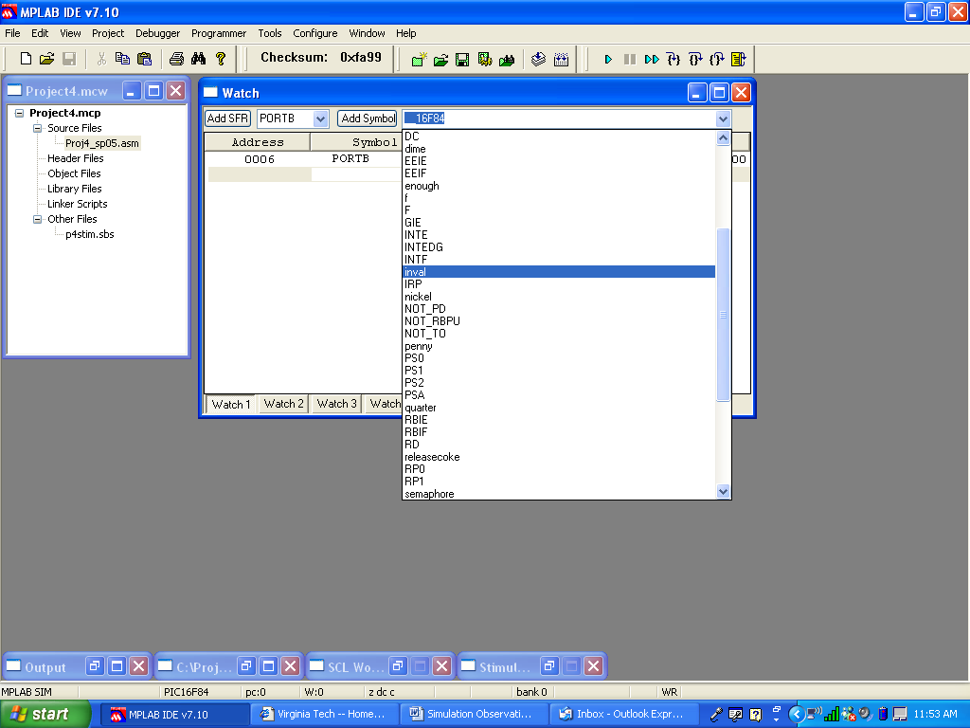
Once a label is selected, press the “Add Symbol” button to add it to the Watch Window.

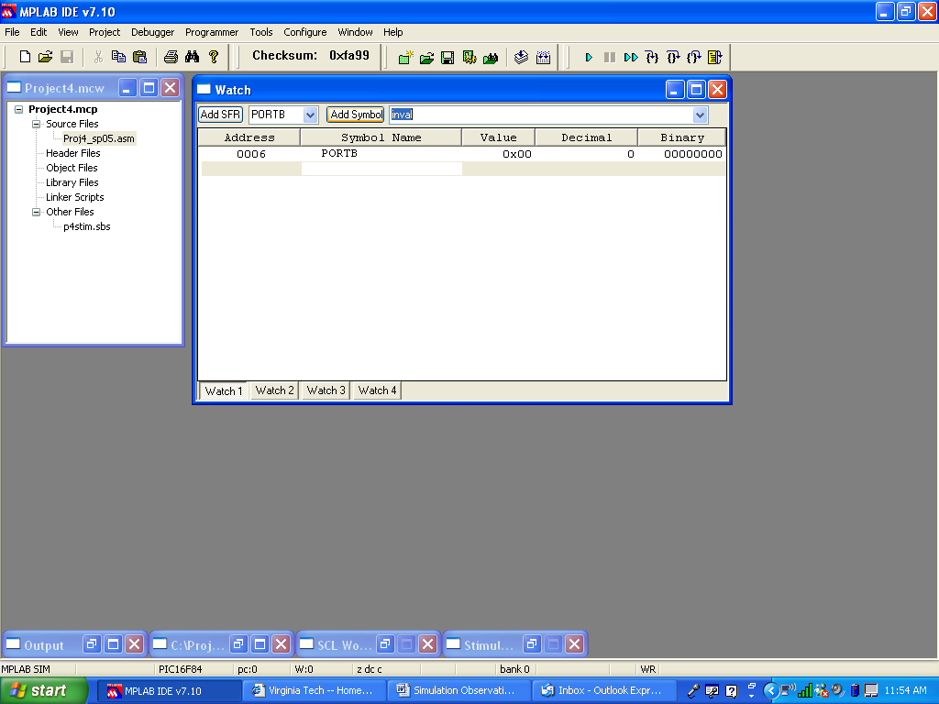

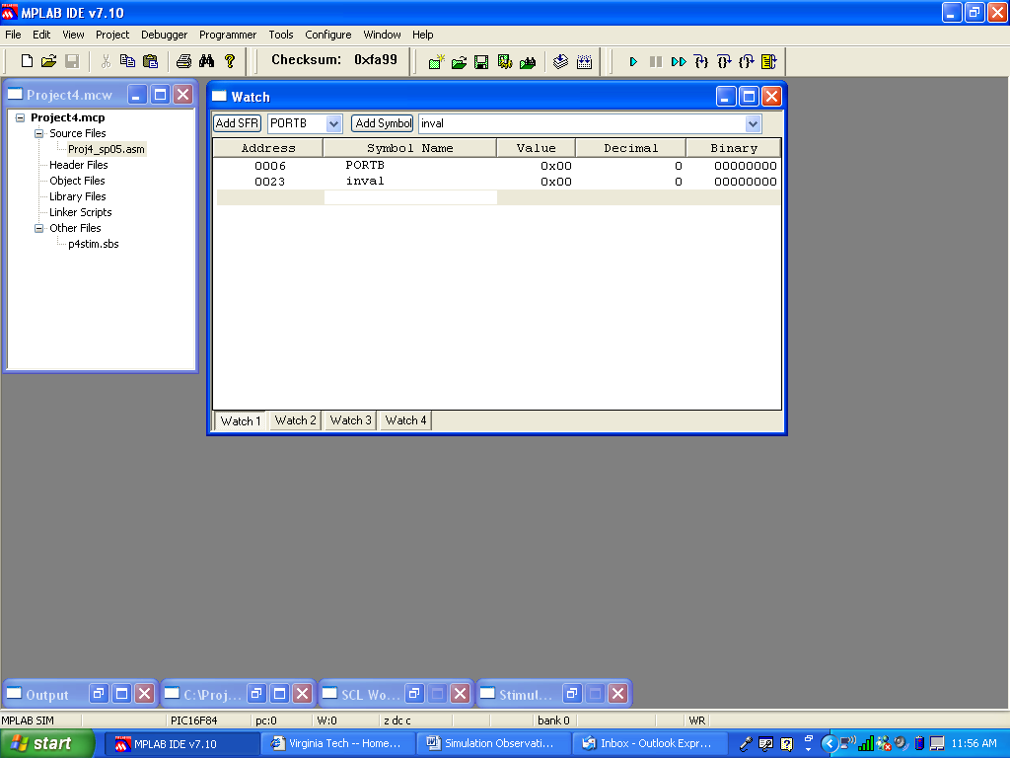

You can also type in the Watch Window. If you enter a file memory address, that address and all of its associated information will appear in the Watch Window, just as though you had selected it with either the “Add SFR” or “Add Symbol” buttons.
Highlight the line under INVAL. Add PORTA to the Watch Window by typing 5 in the Address column.

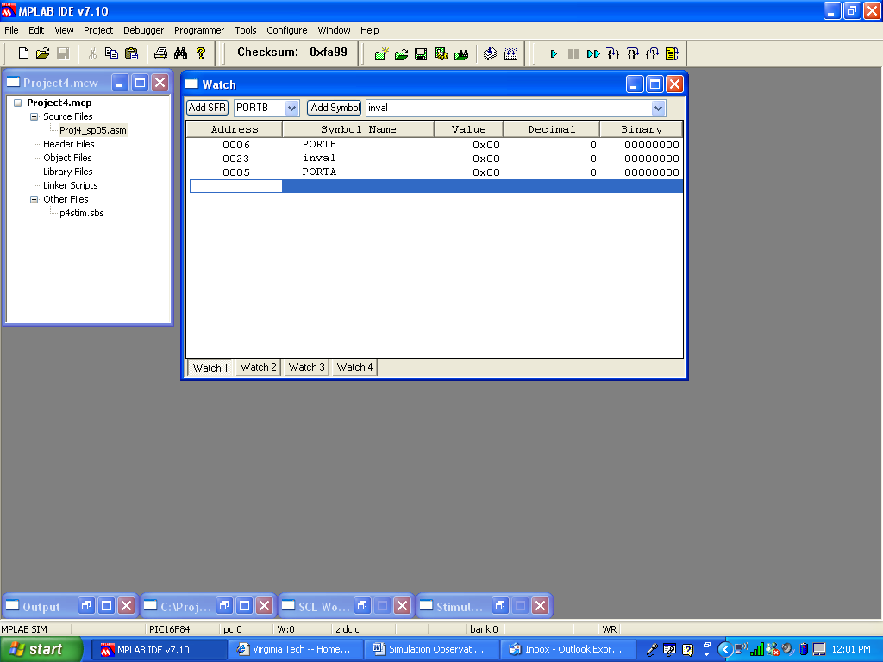

Press Enter and the register appears in the Watch Window.

We don’t need to watch PORTA. Highlight the line of a register you want to remove from the Watch Window.

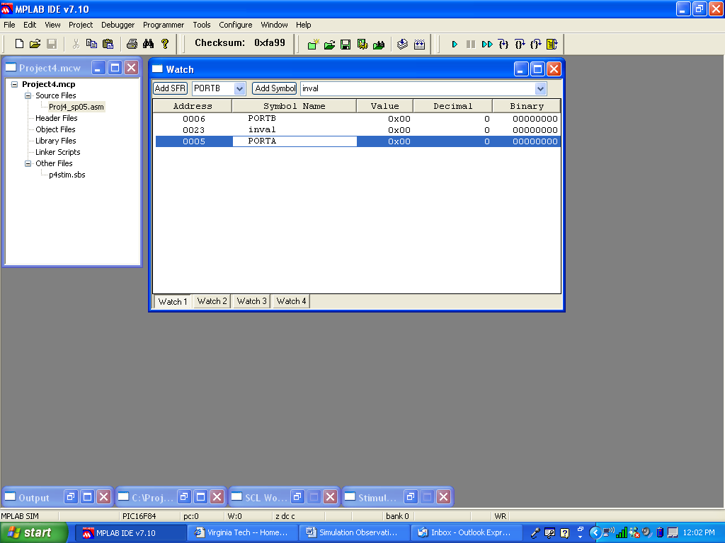

Remove the highlighted line by pressing Delete.

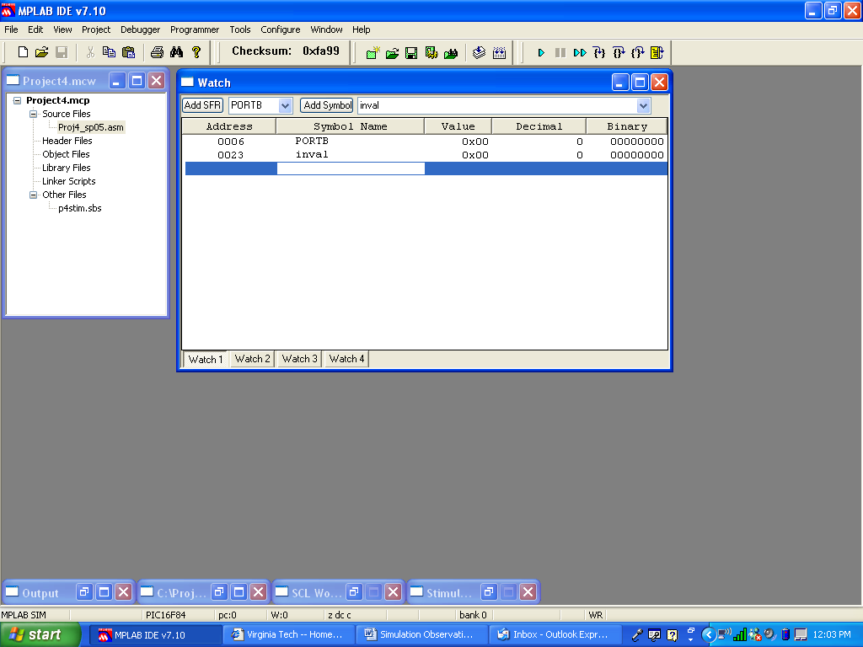
If you use equate statements or the CBLOCK to associate your symbols with their values, you can type the symbol name into the Watch Window. When you do this, you must use the same case that you used in your program.

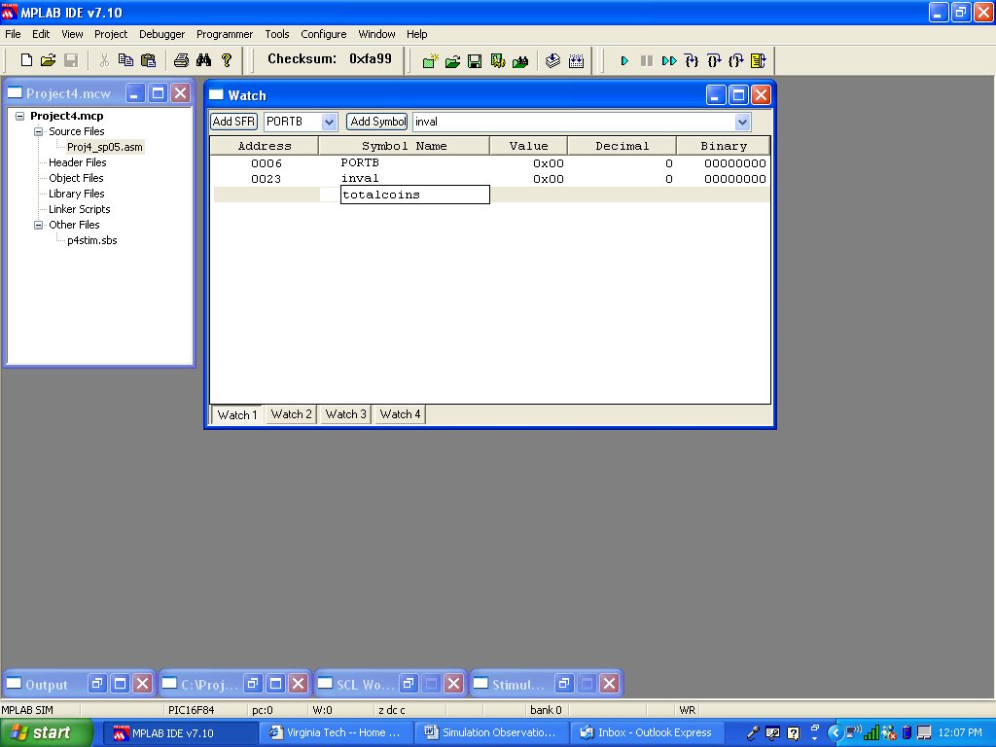

Press Enter, and the address appears in the Watch Window

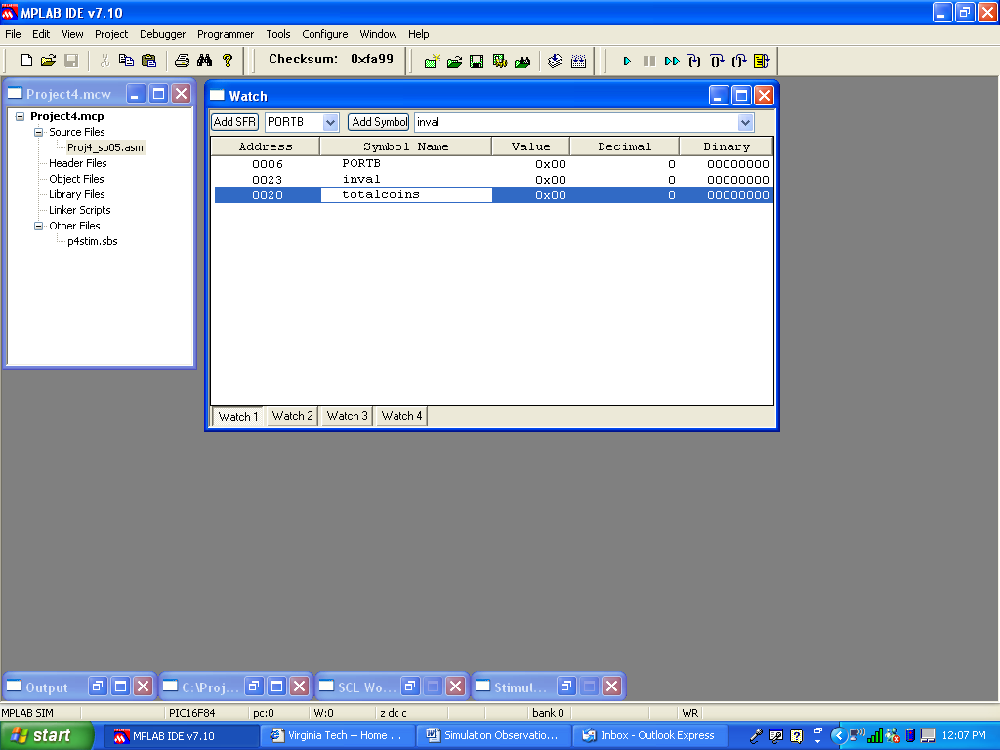
You can’t do this if you used reserve statements to declare your symbols. In the next pair of pictures, I changed my output block back to the way that it was in the original program. When a symbol is designated by a reserve statement, here’s what happens:

First, highlight the line and type the label.

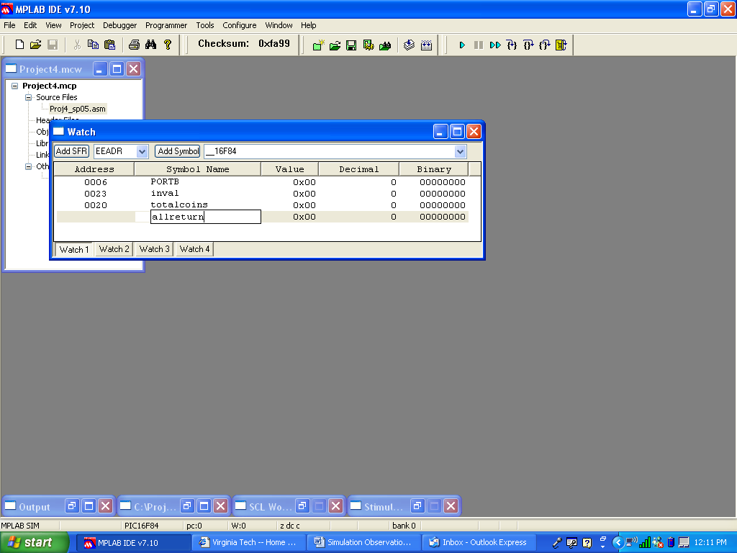

Now press Enter.

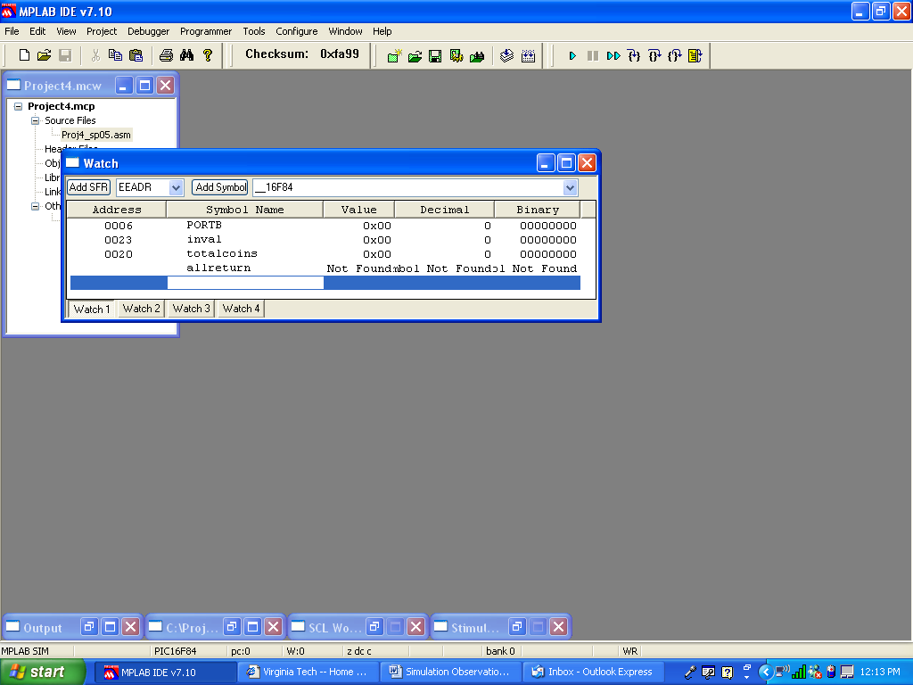

But even if you used reserve statements, you can still type the address of the label into the Watch Window. However, the label value will not appear in the “Symbol Name” column.

Type in the address of the label that we know to be ALLRETURN – address 0x10:

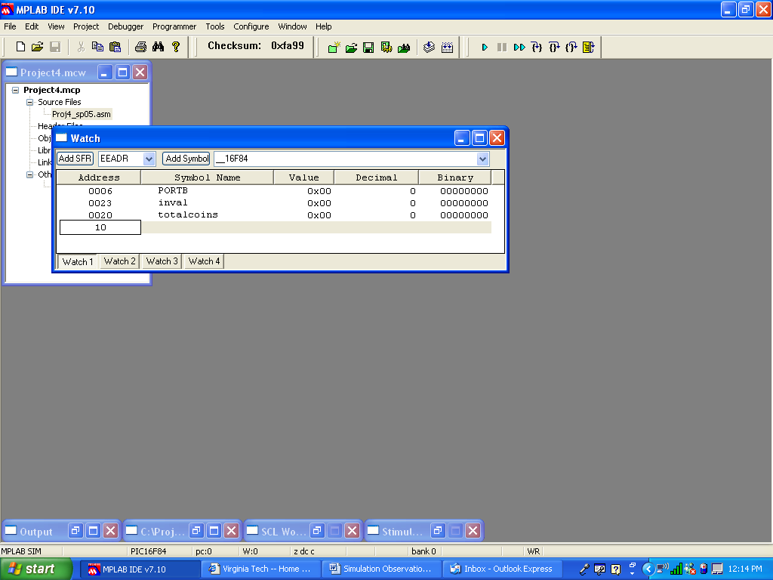

Press Enter, and the address appears, but without a Symbol Name. But since the address is right, it will still follow changes in file memory address 0x10, which corresponds to ALLRETURN.

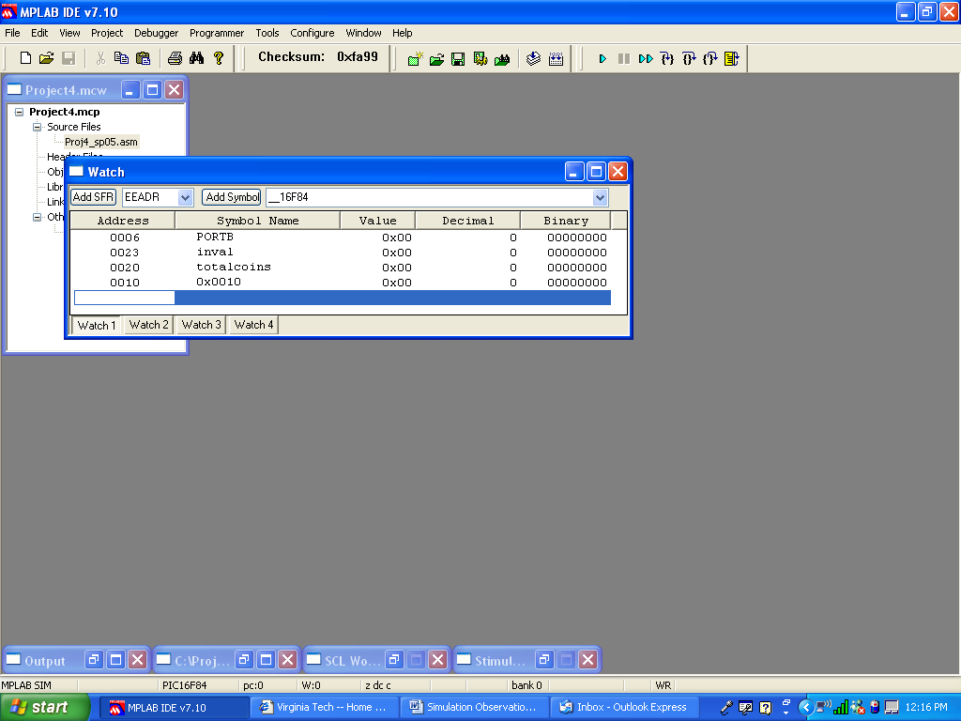

Place all of the important registers into the watch window using any means allowed by the way that your program is organized. In the picture below, I restored the use of CBLOCK for all register labels:

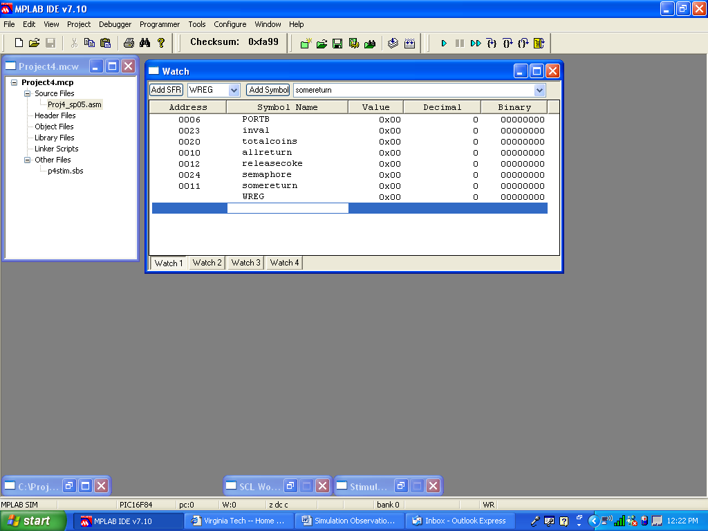

Note the use of the Symbol Name WREG for the working register. WREG appears on the “Add SFR” pull-down menu. WREG has no file memory address, because it is not an element of the file memory.

You probably won’t place the registers into the Watch Window in the order that you want. To change the order of registers in the Watch Window, first highlight the line you want to move:

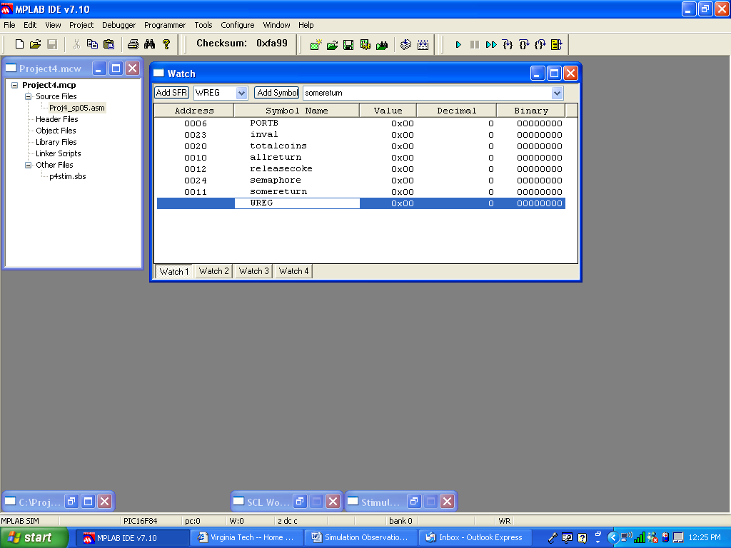
Now click-and-hold, and drag the line to the place you want it to occupy in the Watch Window:

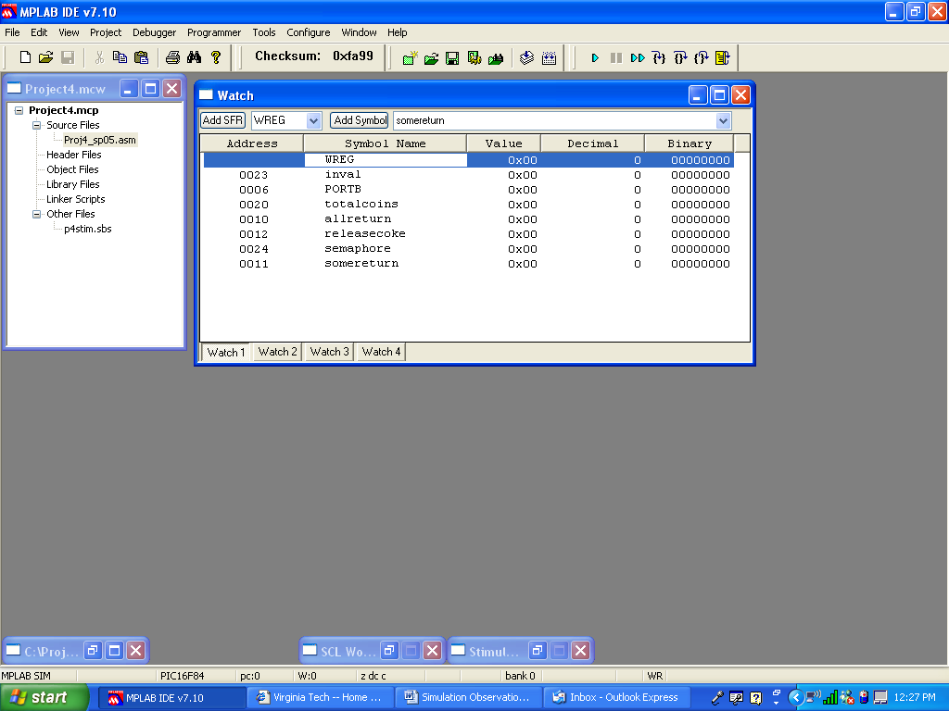

Arrange the registers in an order that makes sense to you.

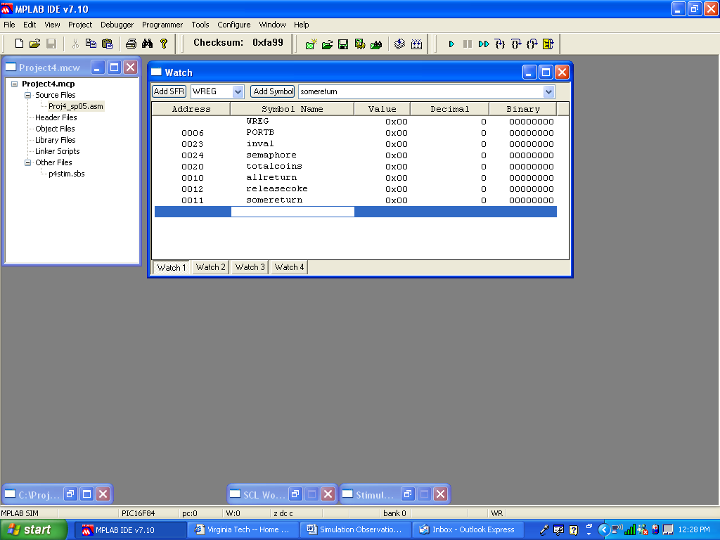

With the Stopwatch active and the Watch Window configured, you are ready to watch your program work.
Executing your program in Animate mode

Make sure that you have selected the appropriate Debugger before trying to simulate the operation of your program.

Now that everything is set up, we can watch the program work. Considering that the “Run” option does not allow us to watch the processor’s register values changing in time, we have two choices.

We could single-step through the program, but given that the stimulus file involves over four thousand instruction cycles, the single-step method will require far too many button presses.

Instead, we are going to Animate the program’s execution. The Animate mode was mentioned in the appendix to the Project 3 specification. In Animate mode, the program executes step-by-step by itself. The green arrow in the code window will point to each instruction as it executes. With the Stopwatch SCL Workbook open, you can note the passing of instruction cycles and match them up to the events that should occur on those instruction cycles. With the Watch Window open, you can observe the changing values in each register.

Once your program builds successfully, your task is to debug the program until it runs through simulation without errors. As a general principle, if all of the register values that you observe are correct, then your program works fine. If you observe a register’s contents taking on a value that you know to be wrong, then the program instruction (or an instruction in its vicinity – perhaps the source of a CALL or GOTO) that caused the change contains a logical error.

Before running the program, you should make sure that you have already taken a number steps indicated in this document:

- Build your program successfully.
- Generate a stimulus control (.SCL) file, and attach it to the present simulation. Follow the instructions that are provided in the specification.
- Open a Stopwatch. Put it somewhere on the screen where you can see it.
- Open a Watch Window and configure it with the register labels or addresses whose contents you want to observe. Put it somewhere on the screen where you can see it.

Run the program in Animate mode by choosing Debugger > Animate, or by clicking on the Animate button on the tool bar. You should be able to see the green arrow move from instruction to instruction at some speed. As this happens, you should be able to see the Stopwatch counting instruction values. You might also see some of the register values in your Watch Window, or in the Special Functions Register (if you happen to have it open) changing as instructions are executed one at a time.

You may find that the Animate mode is running too fast for you to easily observe what is happening. You can change the Animate speed by choosing Debugger > Settings > Animation/Realtime Updates (tab). Change the Animate step time to indicate how many milliseconds you want to pass between steps. For example, a value of 500 will result in the Animate mode stepping through two instructions each second. Raise or lower this value in conjunction with your ability to observe the Animate mode.

Later on in the debugging process, you may want to single-step through a section of your program that is causing problems. You can press the Halt button to stop the Animate mode. Then you can press the Step Into button to step through each of your instructions. During this time, you can still observe the Stopwatch and Watch Window to observe the passage of time and the changes that occur in your file registers. When you are satisfied that the section of code works, you can return to Animate mode by pressing the Animate mode.

What to Watch

Since the first interrupt isn’t scheduled to occur until 100 instruction cycles after the program begins, don’t be concerned if your program sits in the SEMAPHORE polling routine for a long time.

Once the interrupt occurs, the program will jump to the interrupt service routine at address 0x04 – it’s labeled as HANDLER in your program. You should see those instructions executed one at a time; in the process, you should see a number of the register values in your Watch Window changing as well. Once the interrupt service routine finishes, the program will return to the polling routine with the SEMAPHORE bit flag set – it happened in the interrupt service routine. With that bit set, the polling routine check will succeed, and the program will move towards calling the subroutine that you wrote to do the work of the program.

It is a good idea for you to know what each of the events in the stimulus file is supposed to do. For example, the first event corresponds to a quarter being deposited into the soda machine. At the end of the routine that you wrote, you should see all of the registers whose values should have been affected by this coin deposit change to their appropriate values. As more events occur, the registers that are affected will be different. Certain coins being deposited at certain times should only affect TOTALCOINS. Other coins being deposited at other times might provide a sufficient value to trigger COKERELEASE and SOMERELEASE, which requires a certain effect on TOTALCOINS. Other events might trigger ALLRELEASE, which must also require a certain effect on TOTALCOINS. Again, if you can observe the correct values appearing in every register as your program runs from start to finish, then it is likely that your program works.

